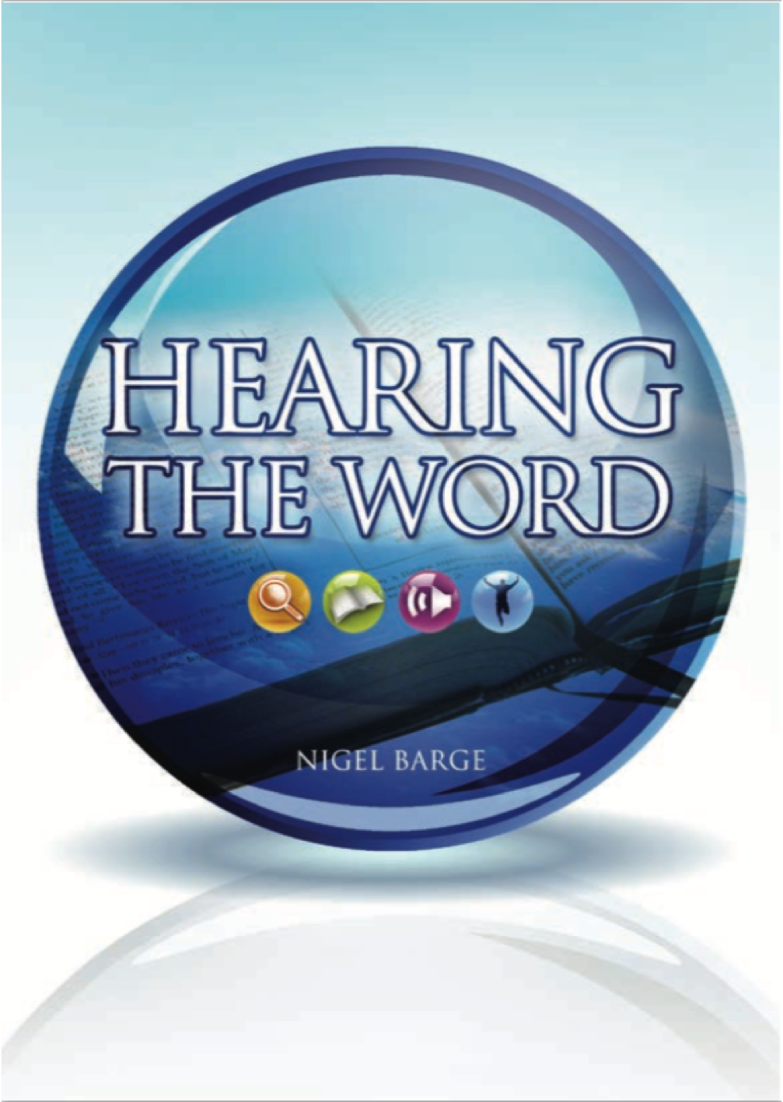

Luke’s Gospel
^{Read it for yourself}

Hearing the Word Read it for yourself
Copyright © Nigel Barge, 2009 – 2021

Email: info@hearingtheword.org.uk
Website: https://hearingtheword.org.uk

The copyright of this booklet, and of the ‘Hearing the Word’ tool and study materials, rests with the author, Nigel Barge. Unless otherwise indicated, its contents are licensed under a Creative Commons Attribution-Non Commercial-No Derivatives 4.0 International Licence (CC BY-NC-ND). Please see the full legal terms there by clicking on ‘License’.
Simplified version: Under this licence, you may copy and redistribute the material in any medium or format on the condition that: you credit the author, do not use it for com-mercial purposes and do not distribute modified versions of the work. When re-using or sharing this work, ensure you make the licence terms clear to others by naming the licence and linking to the licence text. Please seek permission from the copyright holder for uses of this work that are not included in this licence or permitted under UK Copyright Law.

Acknowledgements
I am very grateful to Phil and June Malloch, whose tireless editing,
reviewing and pulling together of materials has enabled the
‘Hearing the Word’ resource to be shared with the wider church.
Nigel Barge, December 2011

Scripture Quotations taken from THE HOLY BIBLE, NEW INTERNATIONAL VERSION
Copyright © 1973, 1978, 1984 by Biblica, the International Bible Society. Used by permission of Hodder and Stoughton Ltd A member of the Hodder Headline Plc Group. All rights reserved.
“NIV” is a registered trademark of International Bible Society UK trademark number 1448790

Resources
The New Bible Dictionary 3rd edition, published by Inter Varsity Press
The New Bible Commentary 21st century edition. A commentary on every Bible book, IVP
www.blueletterbible.org

Sharing the Word

Use
‘Hearing the Word’ can be used alone, with one other person, or in a group

Preparing for a group
Time put in alone beforehand will greatly benefit time spent together.
Work through the stages - LOOK, LEARN, LISTEN, LIVE.
Write down your own questions and answers. *
Format
  - LOOK - Any questions? (Whether answer is known or not!)
Relevant cross references in rest of the Bible?
b. LEARN - Answers to questions?
c. LISTEN - Key verse and Main Point?
d. LIVE - What does it show about God /His grace/ Jesus?
What should I do
n.b. Leave plenty of time for the LIVE section!
By also eating together and a time of prayer, you will have shared
something of the life of the early church! (Acts 2:42-47)

Relevant cross references in rest of the Bible?
b. LEARN - Answers to questions?
c. LISTEN - Key verse and Main Point?
d. LIVE - What does it show about God /His grace/ Jesus?
What should I do
n.b. Leave plenty of time for the LIVE section!
By also eating together and a time of prayer, you will have shared
something of the life of the early church! (Acts 2:42-47)

* The process is explained and practiced in a four-hour course, suitable for all, called ‘An Introduction to ‘Hearing the Word’ https://hearingtheword.org.uk

Remember!
As we gather round God’s Word -
- Listen to the views of others.
- Make room for the novice. (They can join in too when you start by listing ‘Any questions’.)
- Don’t let the ‘knowledgeable’ dominate. Encourage everyone to think for themselves.
- Try to include others, especially ‘seekers’, in your time together.

Background to Luke’s Gospel
The Author
Luke was a doctor and friend of the apostle Paul, who calls him ‘the beloved physician’ and ‘fellow worker’ (Colossians 4:14; Philemon 1:24). He began to travel with Paul at Troas (Acts 16:10). He was close to Paul near the end of his life (2 Timothy 4:11).
He may have come from Antioch in Syria, or Troas, or Philippi in Macedonia. He was a Gentile (i.e. not a Jew). Indeed he is the only non-Jewish writer in the New Testament.
He had carried out careful research (see Luke 1:3; 2:51). He also wrote the story of the early church in the 5th book of the New Testament, whose full title is: ‘The Acts of the Apostles’. It takes us up to Paul’s imprisonment in Rome but not his trial, suggesting Luke finished writing it before that event

The Date of writing
Luke wrote his gospel before Acts (see Acts 1:1), probably before 63AD.

The structure
A The introduction (1: 1 - 4)
B The birth of Jesus (1:5 - 2:52)
C The start of Jesus’ ministry (3:1 - 4:13)
D Jesus in Galilee (4:14 - 9:50)
E From Galilee to Jerusalem (9:51 - 19:44)
F Jesus in Jerusalem (19:45 – 21:38)
G The death of Jesus (22:1 – 23:56)
H The resurrection of Jesus (24:1 - 53)

Its purpose
Matthew and Mark probably wrote their gospels before Luke. Unlike them Luke had not himself witnessed Jesus’ birth, life, death and resurrection, but he had personal contact with many eyewitnesses who had.

He was a doctor, a travelling companion of Paul in his mission to the gentiles (n.b. ‘We’ in Acts 16:11) and was the only non-Jewish writer of the Bible.

He addresses both his Gospel and The Acts of the Apostles to someone called ‘Theophilus’. This may have been a real individual: could he have been an official in Roman government?... Someone who wanted details of Christianity before Paul’s trial in Rome?... Someone who paid Luke’s expenses while writing? Actually, the name means, ‘friend of God’, so it might refer to anyone, in any time or place, who wanted to know the Gospel and be a friend of God.
Themes
Several themes keep reoccurring in Luke’s Gospel
1) Salvation
This was a historical event for all mankind
2) ‘Outsiders’
The Gospel is for all, including those least valued – women, children, the poor, gentiles.
3) The Holy Spirit
He was evident empowering Jesus through his life and ministry
4) The humanity of Jesus
This was especially shown in His recourse to prayer.
5) The deity of Jesus
A fact obliquely referred to during His life but which was evident to the faithful after His death and resurrection.

Information given

For each passage some background information is given. The purpose of this is to try put the reader of today into the same position as a reader of the scripture might have been at the time and place it was written.

This includes:
- Background information
This involves geography, religious practice, customs of that time etc.

- A wordlist
This includes words of the time, the meaning and significance of which
may not be known today.

- Bible connections
These are some relevant cross references in the Bible which may not be familiar to the reader.

By providing this information, we hope to put a person today into a similar position of understanding to those who would have first read it.

